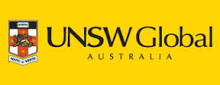
ICAS Educational Assessment - Mathematics
The WHS Mathematics faculty offer students the opportunity to participate in the ICAS program.

ICAS (International Competitions and Assessment for Schools) is a highly regarded assessment program which enables schools to identify students' level of academic performance.

Many families will be familiar with this educational assessment facilitated by UNSW Global Australia, as it often features in the primary schools.

If you would like to know more about the assessment please watch the youtube clip below.
https://www.youtube.com/watch?v=I8Od-80BRZM&list=PL65CC494F6949E431&index=1

