Engineering (100 hours)

Engineering provides opportunities for students to develop knowledge, understanding and skills in relation to engineering and its associated industries.

Projects investigated will include:
- Paddle Pop Stick Tower
- Mouse Trap Powered Car
- Bridge Building with potential entry into the Powerhouse Museum Bridge Building Competition.
- Wind Powered devices

Pupils will:
- Design
- Build prototypes
- Apply mathematics, physics and engineering theory
- Improve and test their model

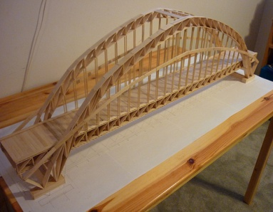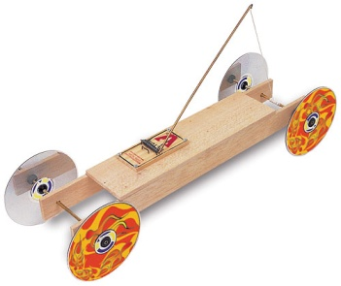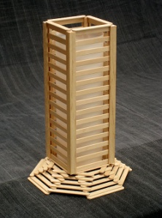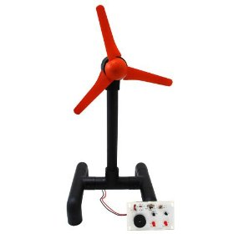

Choosing Engineering will benefit students’ skills in designing, building and evaluating. It will also help to prepare pupils for HSC Engineering, Physics, Extension Mathematics and Mathematics courses.

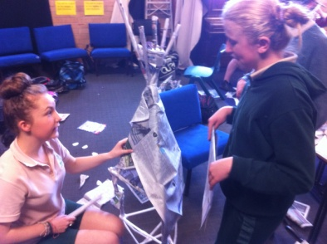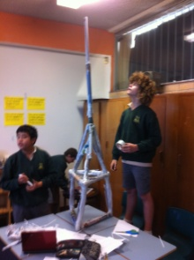

Head Teacher: Ms N Watt

